**Infosys FP 5.0**

**Project**

**Title Page:**

**Project Title:**

**Team Member Details:**

1. Nishkarsh Raj  
   SAP-ID: 500060720
2. Lakshika Parihar  
   SAP-ID: 500060110
3. Shubham Bansal  
   SAP-ID: 500060901

**Branch:** DevOps

**Verical:** Cybernetics

**Semerster/Year:** 3rd Semester/2nd Year

**Project Introduction**

“A great student is one who imagines and adds value to every work he/she does based on knowledge rather than learn what is taught to him/her”

In order to become an extraordinary student, one must get involved in co-curricular activities and must be aware of each and every new practice in one’s field.

This is where Student Chapters in college becomes so important. Apart from the regular studies, they allow us to dwell deep into our field by making us work on project in a practical way, help us by competing against and with each other making us learn importance of teamwork, time management etc.

Our project is related to create a generic working application of Student Chapter body because it is something we could relate to and want to do in future to enhance our talents.

Here, we create a Sign Up page where all the members must create account to access the application and their details would be stored in a Database connected with programming.

The SapId and stored password would allow them to access their account.

Future events, support page, recent trends and news will be shared on the account page.

**Project Module**

1. **Sign-Up Page: (Python)  
   Sign Up page will be used to create the account.  
   Details needed are to be stored in Membership Details Database in Oracle:**1) Name  
   2) SAP ID  
   3) Password  
   4) Student Chapter ID (optional)  
   5) Branch  
   6) Year  
   7) Roll Number  
   8) Gender  
   9) Phone Number
2. **Login Page: (Python)**To access account.  
   Enter Sap Id and password.  
   Check from database.  
   Allow access if present and correct.  
   Else display appropriate error message using Exceptional Handling**.**
3. **Membership Details Database (Oracle) (To be further Normalized)**It will contain all the necessary details about the members in a 3-N Normalized Database
4. **Committee Details Database (Oracle)**Details are:  
   1) Committee name  
   2) Founder  
   3) President  
   4) Goals  
   5) Members (Foreign Key to Member table)
5. **Git Collaboration (GitHub):**This is related to the owner of the Student Chapter but he can add collaborators to modify the application.  
   In this project, all three of us will be the major collaborators.
6. **Events Database (Oracle)**Details about the future Events  
   1) Event Name  
   2) Event Judge  
   3) Committee name (conducting event)  
   4) StartDate  
   5) End Date
7. **Recent News and Trends (File Handling+Python)**Details about current news in world, field centric and also about the college the body works within.  
   All the details can be written in any format of file which will be incorporated in Python access member page using File Handling.
8. **Support and Feedback (Python+File Handling)**Feedback about the committee about what they should do to improve themselves or any complaint can be written here as a text message which will be stored using file handling
9. **\* Future Add-Ons:  
   Database and details about all the committees and their current member and work**

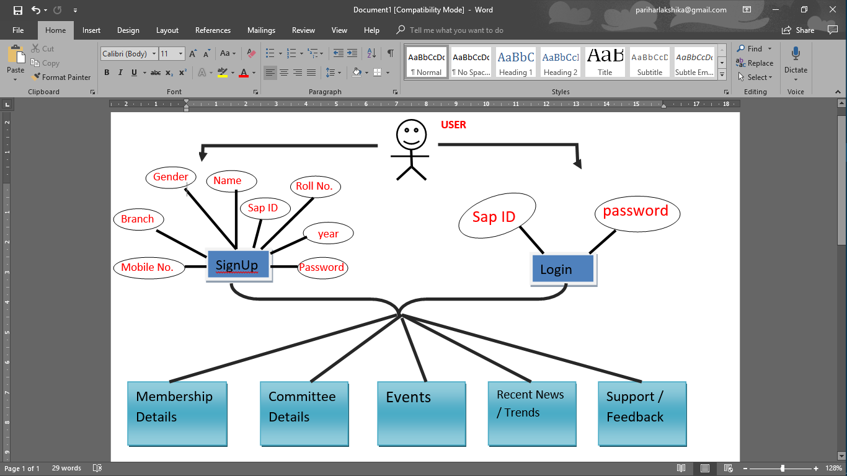**Use-case Diagram**